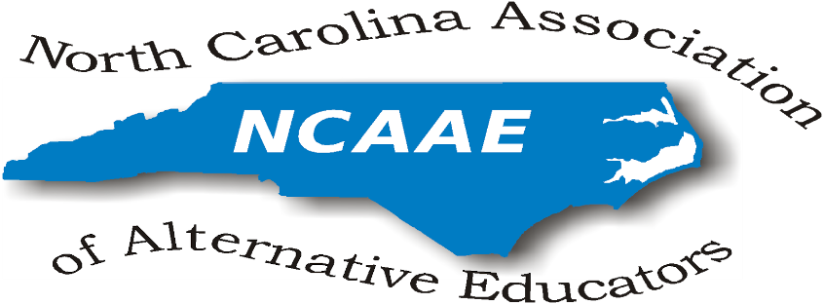

NCAAE Meeting Minutes
September 29, 2017

President’s Welcome/Sign-In:
Dr. Johnson-Green opened the meeting at 11:00 am with introductions of all present attendees.
Present at this meeting were:
James Beasley-Mungin, Jamie Chriscoe, Cleo Evans, Gwen Johnson-Green, Robbie Gupton, Jolanda Jordan, Tammy Miller-White, Luther Thomas, Preston Waddell, Donna Wilde
Represented State Districts (Regions): 1, 3, 4, 6, 8
DPI representatives: Kym Martin (Exec. Director, Center for Safer Schools), Donna Dougherty (Center for Safer Schools, Data Management)
Guest presenter: Col. Ret. Edward Timmons, TarHeel Challenge Academy; Merry Leigh Dameron, UNC Doctoral student
President’s comments:
Dr. Johnson-Green reviewed prior discussions regarding the conference and election of officers.
Officers (beginning January 2018 for installation in November 7 at the conference):
Robbie Gupton, President
Cleo Evans, Vice-President
Donna Wilde, Secretary
Preston Waddell, Assistant Secretary
Richard Armstrong, Treasurer
James Beasley-Mungin, Parliamentarian

Review and Approval of the Minutes of May 19, 2017 Meeting:
(All meeting agendas and minutes are posted on the NCAAE website at
http://ncaaed.weebly.com/ ). The minutes were accepted with the correction that we will only offer 4 grants (not 40) of $200.00 each.

Guest presentations:
Merry Leigh Dameron, doctoral candidate at UNC Charlotte presented the results of her research on the types of referral processes used to assign students to ALPS in NC and to determine the ways in which students and parents are involved in the process. She elaborated on her study and encouraged the Board to attend her presentation at the conference Nov. 7.

Edward Timmons, Tarheel Challenge Academy, explained specifics of this military program that offers discipline, education, and standards of performance and consistency. Literature was provided. He emphasized that Tarheel Challenge supports districts in reducing the dropout rate since students are offered NC diplomas.

Kym Martin introduced Donna Dougherty and explained her position at the Center for Safer Schools with Data Management. They highlighted the benefits of ALPS and how programs have been refined over the past years. Donna will assist with data management related to ALPS. Literature was shared on professional development available online for teachers relating to teen brain development through Homebase. CEU credit will also be available to teachers who complete the training.

Treasurer’s report:
Dr. Johnson-Green gave the treasurer’s report. The balance is currently $7339.40. This is not inclusive of conference registration money.

Committee Reports:
National Alternative Education Association - James Beasley-Mungin shared that the national ALPS conference will be March 5-7, 2018 in Dallas, TX. NAEA shares valuable information in their newsletter and through Twitter @NAEA_ HOPE #NAEACHAT . All are encouraged to investigate their great resources for ALPS teachers and administrators.

State District Reports:
District 1 - Tammy Miller-White shared information from the District 1 conference call session. She surveyed her schools to determine interests and hosted the meeting titled “Advancing ALPs as Avenues of Opportunity for Positive Student Outcomes”.

District 3 - Jolanda Jordan conducted a July conference call session with the purpose of sharing strategies that are successful with ALPS students. They discussed the principals’ pay scale and its effects on alternative school principals. Robbie Gupton plans to share more on this topic at the conference.
Conference Committee Report:
Organizational details were finalized as follows:
Proposals:
Cleo Evans, Jolanda Jordan and Gwen Johnson-Green will evaluate the proposals that are received for the conference. This is a noted change from procedures used in the past. DPI requested that NCAAE Board take responsibility to evaluate and select presenters for our conference in the future.
Cut off for conference proposals is Oct. 6th. The Board will send out samples of conference presentations proposals to entice additional people to register.

Registration -
Fifty-nine people have registered to date.

Monday, November 6, 2017 - Early registration will be open from 5:30-8:30 outside the Hospitality Suite.
Signage and Posters: Donna will put up signage Monday beginning at 4:00 pm then set up the registration table next to the Hospitality Suite. All board members are asked to send a selfie photo to Donna by October 28 so that posters of the Board Members may also be made.

Tuesday, November 7, 2017
Donna will set up registration Tuesday morning at 7:30. Additional assistance is needed.

Name Badges- Valoria and her team will help with registration and will secure name badges. Donna will bring special badges for the Board members to be more recognizable.

Equipment and Materials
Everyone was encouraged to bring chart stands (Donna needs 20). Gwen has 6 projectors and 4 extension cords. Officers will bring extension cords. Gwen will bring flash drive and CD player to display photos for last year's conference throughout the day. ITF will help set this up.
Valoria will bring ITF to help with technology
Gwen will ask Julia to check whether hotel will provide microphones. A large screen and projection system is needed for the luncheon presentation to show the video excerpts of Reject. Julia will help secure this equipment.

Certificates for CEU Credit
Donna will report in October whether the CEU Certificates can be automatically sent once a conference participant completed the post conference surveys. We should not need to print paper CEU certificates this year. Credit awarded will be .6 CEUs (6 hours).

Mini-Grant Proposals and “Shout Outs”
Jamie will send out the mini-grant proposal link to all ALPS. We will award 4 at $200.00 each. Preston, Jamie, and Donna will review the mini-grants to determine final recipients.

Jamie will coordinate “Shout Outs” to recognize special programs and award $25.00 each (4 total) during the luncheon and closing session. It is recommended to give a few awards and “Shout Outs” at the luncheon to encourage people to stay for the closing session.

Take Away Bags
Julia will coordinate the takeaway bags. All Board members are asked to bring 150-200 items for bags and to help stuff the bags after the Hospitality Suite closes.

Door Prizes and Giveaways
Gwen will obtain door prizes.

Luncheon Program
Davidson River Taiko will be playing as people enter the dining room and preparing their sandwiches. A student will lead us in the Pledge. NCAAE will pay up to $200.00 for bus driver fees.

Donna will coordinate luncheon presentation of “Reject” video.
DR Taiko will play again as the luncheon is concluded and people exit.

Gwen suggested that if schools bring additional students to attend the conference that students eat for free. James will coordinate a student session at the conference. Gwen offered to donate $500.00 next year to sponsor students if NCAAE cannot support financially.
Jaime will award 2 “Shout Outs” and one mini-grant and explain the remainder will be given at the closing session.
Closing session
Gwen will introduce Robbie and install officers. Gwen and Jamie will recognize retirements, Principals of the Year, and other recognitions. Gwen will make closing remarks.
Social Media for NCAAE:
Website management: James Beasley-Mungin volunteered to maintain the NCAAE website.
Tamarla Moody maintains our Twitter address @NCAAE1 . Jaime will network with her about setting up Instagram as well.
By-laws:
Robbie suggested we review the bylaws to clarify guidelines for the board members to elect officers. This will be a topic for the January meeting.

The meeting was adjourned at 2:21pm.

Respectfully submitted,
Donna Wilde
Secretary

Next Meeting: October 27, 2017 Conference Call

