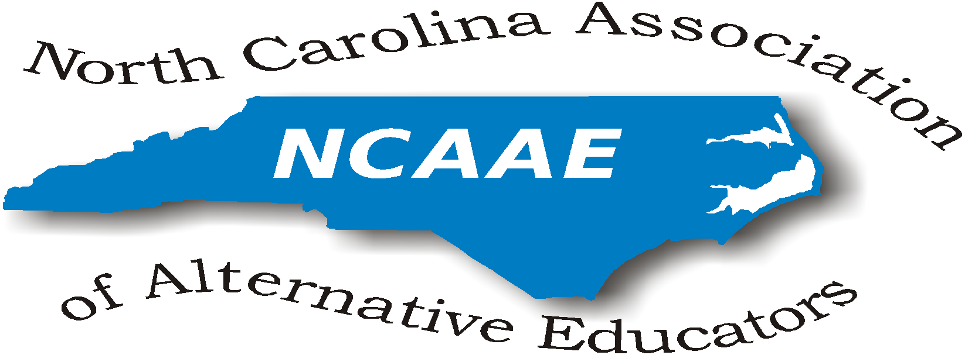
Board of Directors’ Meeting Minutes-- May 19, 2017 11 am – 2 pm

Raleigh, NC (DPI)

Present at this meeting were:
Michael Anderson (DPI), James Beasley-Mungin, Gwen Johnson-Green, Cleo Evans, Jolanda Jordan,
Kym Martin (Exec. Director, Center for Safer Schools/DPI), Julia McCombs, Kevin Ross (Acceleration Academies), Tammy Miller-White, Preston Waddell, Donna Wilde.
Represented State Districts (Regions): 1, 3, 4, 5, 6, 8

President’s Welcome
Dr. Johnson opened the meeting at 11:00 am and requested introductions of all present attendees. She reviewed distributed information, including an article on suicide prevention, recent regulations requiring training on suicide prevention and an article on a House Bill referencing low performing schools and student growth.

Review and Approval of the Minutes of January 27, 2017:
(All meeting agendas and minutes are posted on the NCAAE website at http://ncaaed.weebly.com/ .) The minutes were approved. We noted that the NCAAE website needs to be amended to include the January meeting minutes. Gwen will notify Sarah Evans of this omission.

Kym Martin inquired if NCAAE District Representatives know their State Board of Education District Representatives. She will secure a roster for distribution to the board. Kym shared written information on “Teen 2 Teen- Let’s Get Real” regarding the movie “13 Reasons Why”. Kym stated that DPI does not support the Netflix series “13 Reasons Why” and is developing material for suicide prevention.

Special Guest Presentation: Kevin Ross, Acceleration Academies:
Kevin reviewed the services of Acceleration Academy. He referenced “wrap around services” offered including home visits, social worker services, and content coaches. Their programs focus on dropouts ages 16-21 and their enrollment is credited to the school district. The fee for Acceleration Academy is not paid for by the school district but through a portion of the FTE when the student is enrolled again. Students receive a school district diploma and are asked for a commitment of 8 hours per week plus online work. Cleo offered information that supported the effectiveness of the tenets of this program. Kevin referenced how smaller school districts can partner together to access services.

Treasurer’s Report:
As of April 24, 2017, ending balance $7,339.40. Richard will pay the stipend of $100 to Sarah Evans for maintaining our website this year.

Input from DPI, Mike Anderson:
Mike shared his current job responsibilities and indicated a second person will be working with NCAAE for data management, accountability, and policy. The vacancy for this position will be announced soon. Michael will monitor ALPS while Richard “Dick” Hayes (or his replacement) will address data for accountability.

Committee Reports:
Conference Update for 2017:
Julia secured the Embassy Suites Cary, NC for Tuesday Nov. 7 with the Hospitality Suite Monday, Nov. 6. She will negotiate room rates and lunch options.

Donna shared information on a documentary video called “Reject”. The Board inquired about showcasing this at the fall conference. Donna will secure information. Cleo suggested Manny Scott as a motivational speaker and will secure information on his costs to speak at the conference. Donna will secure the Davidson River Taiko drumming group again for lunchtime music. Donna agreed to facilitate the “Birds of a Feather” session at the conference.

The Board requested Mike invite the new State Superintendent to speak at the conference.

President’s Recommendations:
Gwen proposed that beginning January 2018 the following become standard practices for NCAAE:
- NCAAE should pay the following:
  - President’s association dues, conference registration, and conference overnight accommodations.
- No association dues for the following:
  - Retirees who remain active on the NCAAE Board of Directors,
  - Faith-based partner on the NCAAE Board of Directors,
  - Business/community partner on the NCAAE Board of Directors,
  - DPI representative.
- Continue to sponsor mini-grants and monetary recognitions and if possible, fund amounts up to the following:
    - 10 $200.00 mini-grants for innovative projects,
    - Monetary recognition if an ALPS principal is school district Principal of the Year and school district Teacher of the Year,
    - 40 “Shout Outs” at $25.
Gwen suggested we recognize retirees who are actively volunteering on our Board. The Board approved $100 honorarium to acknowledge the services of three retirees (Preston Waddell, Ken Gattis, and Luther Thomas).

Website management:
Gwen will check with Jaime Criscoe and Robbie Gupton to take over website management.

Election of Officers (beginning January 2018 for installation in November):
Robbie Gupton offered to coordinate the ballot for officers to be sent out in September to the members at large. We suggested a deadline for votes be included.
Gwen declined to continue as president.
The following were nominated and accepted nominations:
- Robbie Gupton, president
- Cleo Evans, as vice-president
- Richard Armstrong, treasurer
- James Beasley-Mungin, Parliamentarian
- Donna Wilde, as secretary.
- Preston Waddell, as assistant secretary

2:29 The meeting was adjourned

- September 29th at DPI 11:00 am - 2:00 pm
- October 27th Conference Call
- November 7, 2017 Fall Conference

Good of the Order: Official Website; ncaaed.weebly.com
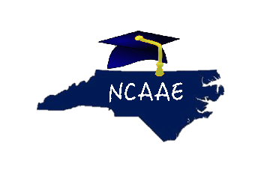
Alternative Education is not an Alternative to Education.

