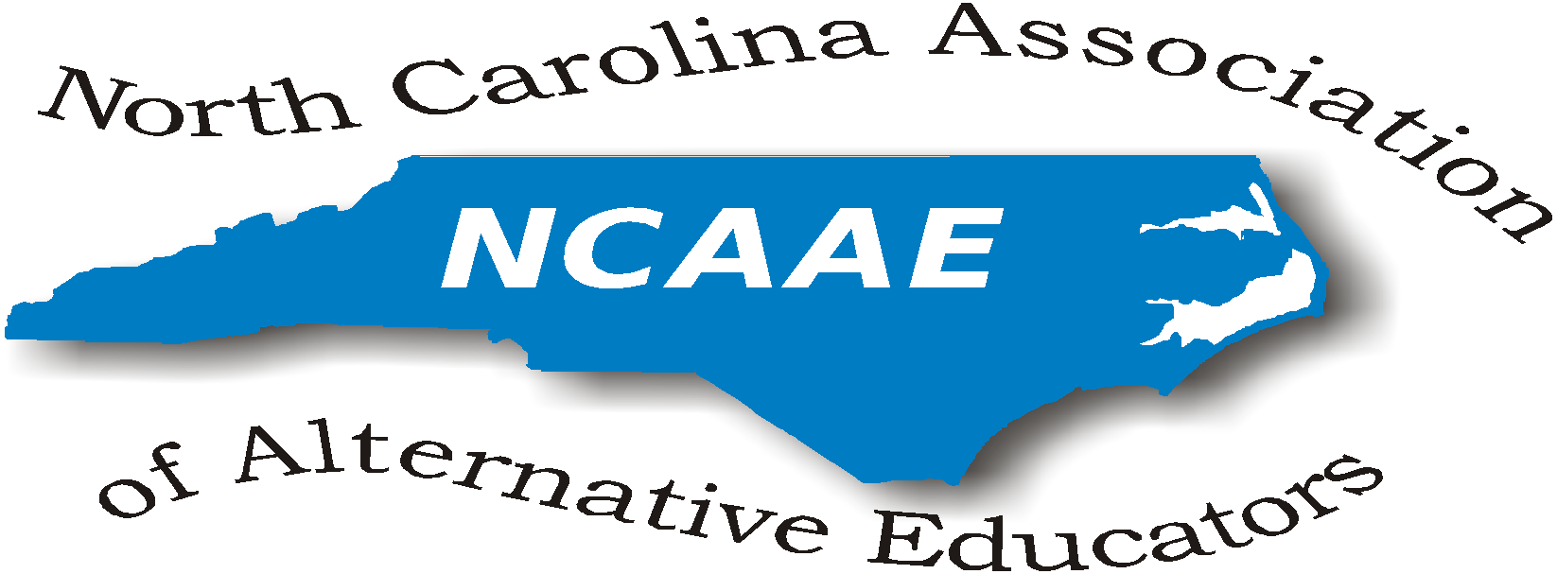

NCAAE
Board of Directors Meeting Minutes (Conference Call)

September 28, 2018

President’s Welcome/Introductions:
President Robbie Gupton opened the meeting at 1:00 pm by thanking all and requested introductions of all present attendees. Gwen Johnson-Green volunteered to take minutes for today’s meeting only. We will need a permanent secretary due to Donna Wilde’s inability to serve at this time.

Present at this meeting were:
Richard Armstrong, James Beasley-Mungin, Jamie Chriscoe, Robbie Gupton, Gwen Johnson-Green, Jolanda Jordan, Julia McCombs, Tammy Miller-White, Marcus Sutton, Luther Thomas

Treasurer’s report:
- Richard Armstrong reported: $1,674.00 in treasure
- Only 3 paid conference registrations at this time

Committee Reports:
Conference Committee:
- Only 13 registered for conference at this time compared to 59 this time last year.
- Storm has impacted conference registrations.
- Email reminders for conference proposals and registration will be sent out weekly.
- A request to Sarah Evans will be sent to post conference reminders to our website.
- Jolanda Jordan reported that no conference proposals have been submitted.
- Jamie Chriscoe and James Beasley-Mungin will work with Robbie to coordinate logistics for conference registration in the absence of Donna Wilde.
- Conference dues: $85.00 includes conference registration and membership into NCAAE
- Marcus Sutton was informed that few hotel rooms are left in our block.
- Julia will check with hotel.
- Conference room numbers were increased by 35 rooms.
- Room rates are: $119.00 per night
- James Beasley-Mungin will contact Paul Walker in Wake County Public Schools to assist with promoting conference participation in Wake County.

Special Discussion:
- Low conference registration as of 9/28/2018 could warrant the need to cancel conference.
- We need 100 participants to host conference without a deficit.
- Julia will communicate with hotel about possibilities of cancellation.
- Julia will communicate with vendors.
- We are asked to recommend vendors.
- Richard informed us that refunds are doable if necessary.
- Recommendations: Make decision at 10/12 meeting
- Tammy Miller-White offered NE Region Conference to be held 10/10. See below.

Plan B for Conference suggested by Julia McCombs if necessary to cancel Conference:
- Abbreviated Conference with luncheon session (10 – 2 or 11 - 1)
- $60.00 fee which includes lunch and membership into NCAAE

ALPS Accountability Model and DPI Contacts:
- Contact Curtis Sonneman at DPI for information and direction.
- Please note change in Accountability Model from Option C to Option B
- Plan in place at DPI to support Alt. Education due to changes in positions
- Karen Fairley at DPI will arrange for meeting space.
- Eric Hall and Marie Petree- are other DPI contacts

Further Business:
- Parking Passes were made available that were previously purchased.

The meeting was adjourned at 1:50 pm.

Next Meeting: NCDPI 10/12/2018

Official website: ncaaed.weebly.com

Respectfully submitted,

Gwendolyn Johnson-Green, Ed.D.
Proud Retired NC Educator

SPECIAL INVITATION/ANNOUNCEMENT TO ALL BELOW

Dear Colleagues,
It is time for our Northeast District 1 Fall 2018-19 ALP Forum. Please complete the survey to assist in identifying topics of discussion. Spread the word to ALPs in our region; we want to reach out to all. Lastly, a special thanks to Dee Biggers (Hertford County) for hosting our Fall 2018-19 ALP Forum.
Date: Wed., Oct 10, 2018
Time: 9:00 AM - 11:30 AM
Meeting Site Address: Roanoke Chowan Community College 109 Community College Road Ahoskie, NC 27910, (Freeland Building)
Meeting Room Information: Freeland Building: Room is located in the center of the building with entrances on all 4 hallways.
Parking Instructions: Park in the lot in front of Building D.
Please RSVP by Sept 26, 2018.
If you have any questions or need additional information, please do not hesitate to contact me. Hope to see you all soon!
Tammy Miller-White
Dean of Students - Accelerated Learning Center
Perquimans County Schools
Office (252) 426-5741
Email tmiller-white@pqschools.org
TEACHING - LEARNING - CHARACTER - INTEGRITY - ACCOUNTABILITY
Advancing ALPs as Avenues of Opportunity For Positive Student Outcomes

