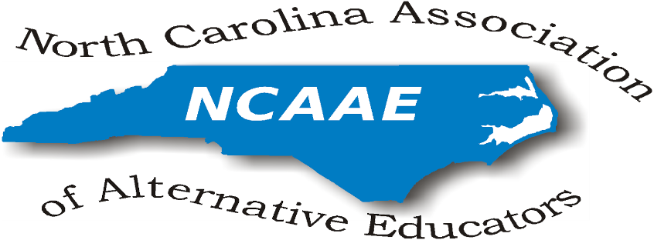

NCAAE Meeting Minutes
March 18, 2016

President’s Welcome/Sign-In:
Dr. Johnson-Green opened the meeting promptly at 11:00am and requested introductions of all present attendees. Dr. Johnson-Green gave accolades to Dr. Ken Gattis, our DPI representative, for arranging the meeting space at DPI so that the presence of NCAAE is more pronounced in Raleigh.

Present at this meeting were:
Gwen Johnson-Green, Vernon Lowery, Donna Wilde (teleconference participant), Rod Dupree, Mark Grega, Beth Bradley, Stacy Williams, Cleo Evans, Bobby Dixon, Ken Gattis, Richard Armstrong, Preston Waddell, Luther Thomas

Represented State Districts (Regions): 3, 4, 5, 6, 8

Review and Approval of the Minutes of January 29, 2016 Meeting:
(All meeting agendas and minutes are posted on the NCAAE website at http://ncaaed.weebly.com/ .)

Minutes from the January 29, 2016 meeting were reviewed. Preston Waddell motioned to accept the minutes. Donna Wilde seconded the motion. The minutes were accepted.

Treasurer’s Report:
Balance:
- Richard Armstrong indicated the treasurer's report would be emailed to all Board members to be discussed at the meeting May 20, 2016. Dr. Johnson-Green reiterated that NCAAE has a balance of $5,011.98. It is recommended that we use part of the funds in our treasure for special grants that would be made available to alternative educators and alternative education schools.

Reimbursements:
- The Board agreed to reimburse all conference expenses to Julia McCombs including any interest accrued on her credit card that was related to NCAAE. Richard Armstrong was asked to follow up on this detail.
- The Board agreed to provide a stipend to Sarah Evans for maintaining the website. Preston Waddell suggested we include this as an annual expense. Dr. Johnson-Green will send out an email to solicit feedback and suggestions for the amount to give her.
- $100 was provided the past year.

Committee Reports:
Dr. Johnson-Green will communicate with our webmaster to update the committee roster posted on our website.

Membership/Publicity
- Dr. Vernon Lowery mentioned the need for more communication and updated information on the DPI website regarding schools that qualify as ALPS (Alternative Learning Programs and Schools). Dr. Ken Gattis requested Board members notify him if and when we are aware of outdated information in various State Districts. Dr. Lowery indicated she is coordinating better communication in her state district and shared ideas.

National Connection
- Donna Wilde came off this committee; Dr. Beth Bradley offered to chair the committee. We will request a report from Valoria Burch and Jamie Chriscoe who are presently at the national conference for our May meeting.

By-laws and Procedures
- Dr. Gattis reported updates on the ALPS standards. He will send the edited document, 36 pages vs over 100 pages, to all Board members for review. He requests comments and suggestions from Board Members to be sent to the Standards Committee, Chairperson Valoria Burch.
- Cleo Evans noted how the North Carolina Standards currently parallel the National Standards, having completed a comparison less than 2 years ago. Cleo will join the Standards Committee.
- The Board noted Dr. Gattis’ leadership with this DPI endeavor. After the Standards Committee convenes, suggestions and modifications will be taken to the State Board of Education for approval.
- Ken will also forward copies of the ALP Desk Audit to all.

Nomination Committee:
- Members interested in holding office should notify Luther Thomas, Preston Waddell, Robbie Gupton or Valoria Burch by our May meeting. Induction of officers will occur at the Fall 2016 Conference luncheon.

Conference Committee:
- Dr. Stacy Williams, Dr. Beth Bradley, and Mark Grega joined the conference committee. Sarah Evans will update our roster on the website.
- The NCAAE Fall 2016 conference will be at the Embassy Suites Hotel in Cary, NC November 14-15. Monday evening will offer early registration and Hospitality Suite, 5:00-9:00pm. Tuesday, November 15 sessions will run from 9:00 am - 3:00 pm.
- We were not able to secure prime dates (Thursday evening - Friday) for the conference since we are in competition with other associations for preferable dates.
- Later discussion recommended the conference include opportunities for various school systems to collaborate, repeating the Birds of a Feather session and adding breakout sessions for State District Meetings. [Note: The term Regions is now changed to State Districts to designate schools in a particular area as indicated on the State Board of Education District Map. Dr. Johnson-Green will notify Sarah Evans, webmaster, of the changes.
- We plan to include a CD video running throughout the day at the registration tables of photos from the previous year’s conference.
- Final voting and induction of officers will take place at the conference.
- Luther Thomas will coordinate with Julia McCombs a Town Hall Meeting (panel discussion) during lunch to be provided by Acceleration Academies. Extensive discussion ensued regarding Acceleration Academies. For further information, contact Luther Thomas.
- It was recommended that ten small grants of $200 each be awarded to alternative educators and/or alternative education schools. Bobby Dixon recommended that NCAAE initiate an Alternative Education Teacher of the Year (TOY) distinction. Discussion included the use of these funds for Teacher of the Year recognitions for alternative schools. More dialogue on this initiative will be held with the Conference Committee.

Dr. Johnson-Green called for a motioned to adjourn the meeting at 1:59. The motion was carried.

Respectfully submitted,
Donna Wilde, Interim Secretary

