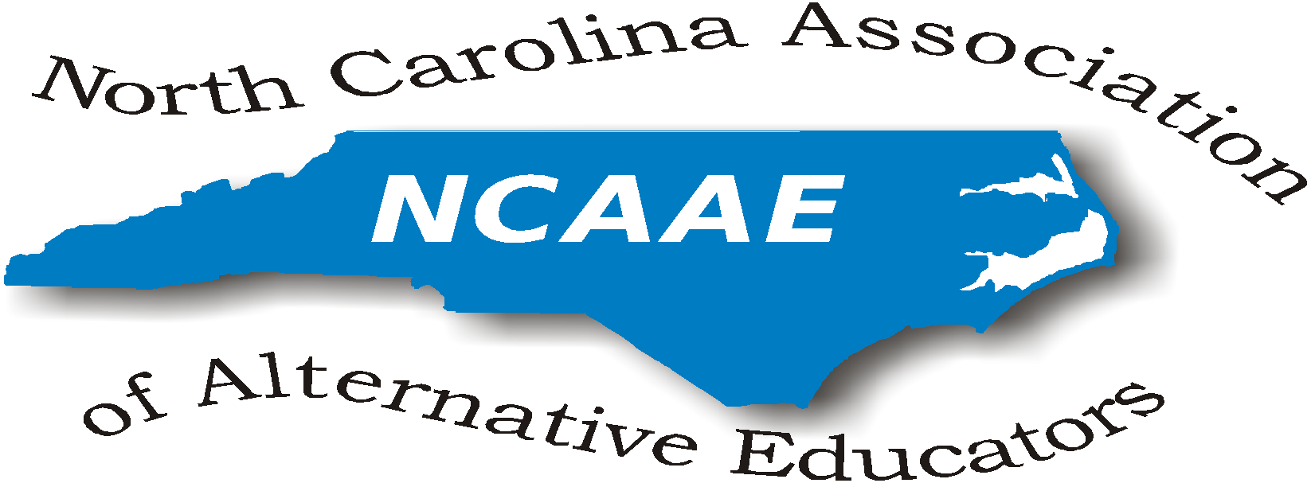

NCAAE Meeting Minutes
January 29, 2016

Dr. Johnson-Green opened the meeting promptly at 11:00am and requested introductions of all present attendees.

Present at this meeting were:
Valoria Burch, Vernon Lowery, Donna Wilde, Sherry Jones, Cleo Evans, Jamie Chriscoe, Toni Ingram, Edward Holmes, Bobby Dixon, Ken Gattis, Diana Heath, Charles Garrett, Richard Armstrong, Preston Waddell, Rhonda Fletcher, Robbie Gupton, Luther Thomas, Rod Dupree, and Julia McCombs

Minutes from the September 11, 2015 meeting were reviewed. Robbie Gupton moved that we accept the minutes as printed. Donna Wilde seconded the motion. The minutes were accepted.

Richard Armstrong presented the Treasurer’s Report. General discussion of deposits and checks for reimbursement ensued. Dr. Johnson-Green noted that after all conference expenses cleared, the ending balance is $5,011.98. The conference was very profitable.

Committee membership, roles and responsibilities were discussed. Dr. Johnson-Green clarified the role of the National Connection Committee: provide general information from the National Alternative Education Association. She asked who planned to attend the national conference. NCAAE agreed to pay half of the registration fee for our members who attend.

Lengthy discussion of bylaws regarding appointed and elected positions ensued. Bylaws require 60 days after the nomination committee is appointed before the slate of officers can be presented, therefore the final slate of officers, board members, and regional representatives will not be finalized until March.

Clarification was sought regarding committee meetings. Modifications to the agenda included waiting for committee reports for the March meeting and in the interest of time, focusing on the formation of the Nomination Committee. Robbie Gupton volunteered to chair the Nomination Committee. Preston Waddell and Valoria Burch also were appointed to the committee. The Nomination Committee will be responsible for developing a slate of officers and regional board representatives to present to the membership. Current regional representatives were given the opportunity to remain on the Board or descend. New members at this meeting were solicited for interest in working on the Board. Two members expressed interest in being Regional Representatives (Vernon Lowery Region 4, Jamie Criscoe Region 4).

After extensive discussion, the Board opted to appoint interim officers (Secretary, Vice President, Parliamentarian) as allowed in the by-laws. In July, we will resume by-law expectations. Since the new year begins in July, the ballot will go out in July for voting in September. The electronic ballot will be available on the NCAAE website both through the conference registration and printed ballot. The final voting and count of election will take place at the conference in November. The induction and announcement of the officers and Board Members will be announced at the conference luncheon.

Dr. Johnson-Green appointed Donna Wilde as Interim Secretary, Preston Waddell as Interim Vice- President, Jamie Chriscoe as Interim Parliamentarian, and Valoria Burch, Robbie Gupton and Diane Heath as the Nominating Committee. Regional representatives were also appointed: Bobby Dickson (Chatham Co., Region 5), Cleo Evans (Edgecombe Co., Region 3), Charles Garrett (Yadkin Co., Region 7) . All accepted the positions. Since these appointees are interim positions, those who wish to be considered for the slate of officers and the Board must make this known to a Nomination Committee member.

Dr. Johnson elaborated on concerns about out of school suspensions, restorative justice practices and alternatives to out of school suspensions. Cleo Evans reported DVD video that impacted her school regarding the obstacles of at risk youth, ‘Turning the Page,’ by Manny Scott.

Ken Gattis identified the need for revisions to the Alternative Learning Programs and Schools
Standards and Implementation Procedures. He indicated his concern was that the standards are lengthy, document has unclear clauses and need updates regarding the accountability model and growth models. Several committee members stated that the role of NCAAE is to view standards and make suggestions to DPI, and that the authority to update and edit Alternative Learning Programs and Schools Standards and Implementation Procedures rests with DPI. Ken Gattis indicated he would edit and update the document.

Valoria Burch and Jamie Chriscoe plan to attend the national conference in Florida in March. The Board agreed to pay half of each of their registration fees. Julia McCombs suggested that a team from NCAAE present at the Collaborative Conference in March (formerly Closing the Achievement Gap Conference).

Suggestions were made for the agenda of the March meeting:
- Robbie Gupton stated that those interested for the ballot of officers should make your desires known to a Committee member. Once officers are secured, any gaps for positions will be further addressed. The final ballot of the slate of officers will be closed by July.

Dr. Johnson-Green motioned to adjourn the meeting at 2:04. Diane Heath approved and Donna Wilde seconded.

Respectfully submitted,
Donna Wilde

Items of information referenced at this meeting:
NCAAE Fall Conference
November 3-4 (Nov 3 Registration/Hospitality Room: Nov. 4 Full day conference)
Embassy Suites Cary NC

National Alternative Education Association Conference
March 16–19, 2016
Sawgrass Marriott, Ponte Verde Beach, FL.
Further information available at http://the-naea.org/NAEA/ or http://the-naea.org/NAEA/?page_id=1675

