Agenda for Board of Directors Meeting – November 1, 2019 1:00 pm – 1:33 pm
Conference Call

President: Welcome attendees on the call (Robert Gupton, Tammy White, Richard Armstrong, Julia McCombs, Theresa McGowan)
- Sent out registration link and emailed Sarah Evans regarding website
- Approximately 16 people have registered for the conference

Planning for Spring 2019 Conference
- Richard Armstrong reported four people from Carteret County Public Schools sent a check
- Guest Speaker (Lawyer Charles James ) potential guest speaker
- Robert Gupton will send email to Jolanda Jordan and Cleo Evans regarding proposals process and obtain presenters for breakout sessions. Ideas include:
  - Literacy
  - Discipline – (Lisa Taylor, NCDPI)
  - Sheriff Department
  - Closing Remarks (Mr. Ellerbee, NCDPI)

- Julia McCombs- Request names of vendors to host “ Thursday Night” and door prizes ( each school can bring a door prize)
- Tammy White- Recommended, Lisa Taylor as a potential presenter at the conference. Tammy will email contact information and Theresa McGowan will email Lisa Taylor regarding her interest.
- Robert Gupton- Discussed voting in new board members and their requirements; He will send an email on November 4, 2019 regarding the following items:
  - Conference Registration
  - Presenting/Proposal Link
  - Vendor names interested in attending the conference email Julia McCombs

Future Board of Directors’ Meeting:
- Meet Friday December 13, 2019 at 1:00 pm. Conference Call

Good of the Order: Official Website; ncaaed.weebly.com
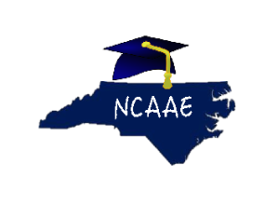Alternative Education is not an Alternative to Education.

