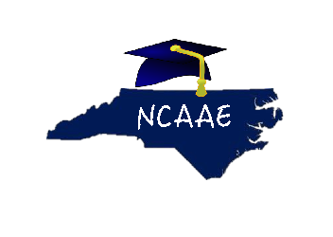
June 25, 2015

Dear Alternative Education Colleagues:
The North Carolina Association of Alternative Educators (NCAAE) needs you. We are a voice for alternative educators and can become a formidable force as we advocate for our students and colleagues. We can identify many reasons why you should join our ranks of alternative educators at-large in our great state of North Carolina. Among the many reasons alternative educators should join NCAAE are:
Reason #1: Learn, Network, and Share Knowledge.
NCAAE enables us to tap into the wealth of expertise among us.
Reason #2: There is something for everyone: Conferences, Valuable Blogs, and a Newsletter are forthcoming. We can inspire one another.
Reason #3: We are connected to the National Alternative Education Association (NAEA). North Carolina members attend NAEA conferences throughout the country and have been chosen as conference presenters.
Reason #4: Our work for our students is not in vain.
Reason #5: Without YOU, there is no US.
Are your ready to join the FORCE? Join anytime. Membership is only $25.00 per year. Conference registration is only $50.00 for members and $75.00 for non-members. Our Fall 2015 Conference will be held November 5th and 6th at the Embassy Suites in Cary, NC. We promise an unparalleled experience for all. See you in Cary.
Sincerely,
Gwendolyn Johnson-Green
Gwendolyn Johnson-Green, Ed.D.
NCAAE President
ncaaed.weebly.com

Alternative Education is not an Alternative to Education.