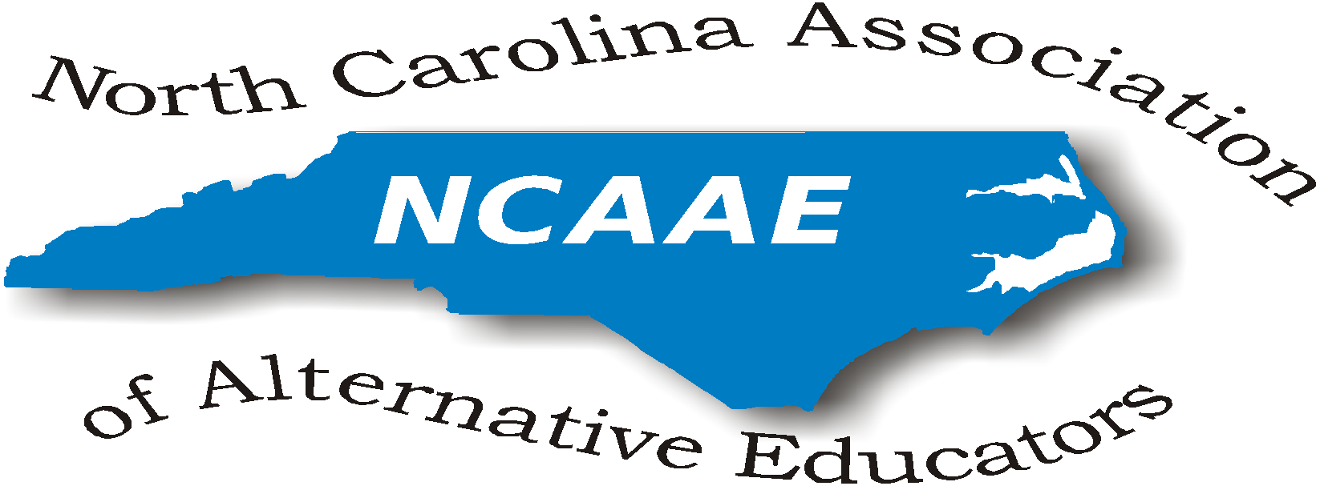

NCAAE
Meeting Minutes
February 16, 2018

President’s Welcome/Sign-In:
President Robbie Gupton opened the meeting at 11:00am by thanking all and requested introductions of all present attendees.

Present at this meeting were:
Cleo Evans, Bobby Green, Gwen Johnson-Green, Robbie Gupton, Leon Hynes, Julia McCombs, Tammy Miller-White, Luther Thomas, Preston Waddell, Donna Wilde (by phone)
Represented State Districts (Regions): 1, 3, 4, 8
DPI representatives:Tammy Howard (DPI Accountability Director), Curtis Sonneman (DPI Accountability), Donna Dougherty (DPI - Safe Schools)
Guest presenter: Joe Warden, Odyssey Software

Review and Approval of the Minutes of September 29, 2017 Meeting:
(All meeting agendas and minutes are posted on the NCAAE website at
http://ncaaed.weebly.com/ ). The minutes from our September meeting were reviewed and approved by board vote.

Guest presentations:
Joe Warden discussed the uses for Odyssey Software. Robbie expressed thanks to him for paying for Board Member lunches today.

Treasurer’s report:
Robbie Gupton gave the treasurer’s report. The balance is currently $1595.89 in checking account and $30.25 in share account.
Robbie expressed concern over the low balance in the account compared to the September balance. This was because no vendor paid for the conference luncheon as in the past, so NCAAE paid for the luncheon. Conference expenses were as follows:
$5682.82 cost of the venue
- $4459.19 cost of the luncheon
- $884.33 for breakfast (Apex Learning paid $500 towards this)
- $339.32 Wifi, microphones and podium

Committee Reports:
Conference Committee:
Robbie Gupton is housing NCAAE licensed REJECT video and educational materials.
NCAAE purchased an association license for the film, making it available to all State District Reps. It is not appropriate for school-wide showing, but would be available if the State District Reps wanted to collaborate with ALPS in the regions.

Responses from the conference evaluation survey were discussed. Feedback included having more break out sessions. If 10-15 break out sessions are scheduled, we will need to send out information about the conference and request proposals in May.

The fall 2018 conference will be at the same location, Embassy Suites Cary on November 30 with early registration and Hospitality Suite on November 29, 2018. Thank you to Julia McCombs for securing the location.

ALPS Accountability Model:
NCAAE had a history of involvement with DPI to create the current accountability model, offering 4 options for ALPS. Through discussions, DPI acknowledged that the “one size fits all’ philosophy doesn’t work for ALPS and developed a model specific to alternative schools.

The majority of schools in the state chose Option C using a Change Rating determination [Maintaining, Progressing or Declining] based on 60% growth 20% proficiency and 20% persistence.

Recently, the State Board of Education received information from the USDE indicating all schools in a state must have a uniform accountability model, where ALPS may not have a different accountability model than traditional schools. The NC State Board of Education chose to maintain our current model and will be in further discussion with the USDE.

Tammy Howard explained the General Assembly gave the State Board of Education the prerogative to review the accountability model. There is the suggestion of a waiver. Any waiver requested by NC to USDE would have to include only one option, one model, not one model with four options in the model. Tammy elaborated on this indicating we have to have an model with Grades A-F but how we determine this grade may be different.

Tammy indicated that other states as in the same situation as NC. She mentioned Florida and Nevada are in the same quandary as NC with needing to revise the accountability model for ALPS. Curtis Sommeman indicated other states are also displeased with the methodology professed by USDE since USDE is looking through the lense they want to hold ALPS accountable to just the same as traditional schools, even though many of our students enter already’ off-track’ to graduate.

Curtis explained that there are two different reporting systems- one federal and one state. The North Carolina School Report Cards report the state calculation only. Since the USDE requires all schools to have the same formula, North Carolina will be reporting 80% proficiency and 20% growth for our federal calculation, but DPI wants to maintain Options A-D for the state calculation. We would, however, have to report a letter grade, not a change rating to be consistent with traditional schools. The letter grade may be the same, but the calculation to get this grade may be different for ALPS.

One caveat in the law refers to the number of students tested in a school. If a school has less than 30 valid test scores, the scores are sent back to the base school. The students must have been enrolled at least one semester or one half the school year at the school to be included in the calculation.

Some ALPS have students transition in and out in less than a semester, therefore, these test scores would not be included in the calculation and would be sent back to the base school. In this case, the ALPS would get the same letter grade as the base school where the majority of the students came from.

Robbie reminded the Board that in the original discussion of Option C, a growth designation was not included but rather, the letter grade. It seems like we are returning to the original way of thinking for this option.

The meeting was adjourned at 2:05.

Respectfully submitted,
Donna Wilde
Donna Wilde

