Agenda for Board of Directors Meeting – June 14, 2019 11 am – 2 pm
Raleigh, NC (NCDPI)

President’s Welcome/Sign-In/Introductions -- Thanks to Host & Partners (5 minutes)

Treasurer’s Report: Richard Armstrong (10 minutes)
Reimbursements/Today’s meeting expenses/ Budgetary Concerns/Dues, etc.

Reflection & Feedback from Spring 2019 Conference (30 minutes)

Preliminary Planning for Spring 2020 Conference (30 minutes)

Lunch & Meet (60 Minutes)

Updates/reminders from DPI Representative (30 minutes)

Districts Report Out: (15 minutes)

Future Board of Directors’ Meeting:

Good of the Order: Official Website; ncaaed.weebly.com
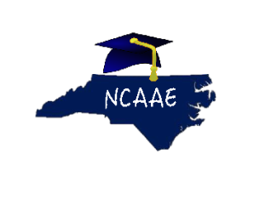Alternative Education is not an Alternative to Education.

