Agenda for Board of Directors Meeting - February 1, 2019 11 am – 2 pm
Raleigh, NC (NCDPI)

President’s Welcome/Sign-In/Introductions -- Thanks to Host & Partners (5 minutes)

Treasurer’s Report: Richard Armstrong (5 minutes)
Reimbursements/Today’s meeting expenses/ Budgetary Concerns/Dues, etc.

Preparations for March 15 Conference
- Presenters and Keynote Speakers – Report Out
- Registration report
- Facilities – Needs and Preparation
- Materials Needs – Badges, Posters,….

Lunch & Meet (12-1)

Review of Conference Prep and Roles (30 minutes)

Districts Report Out: (15 minutes)

Future Board of Directors’ Meeting:
- Conference Call – Date ?

Good of the Order: Official Website; ncaaed.weebly.com
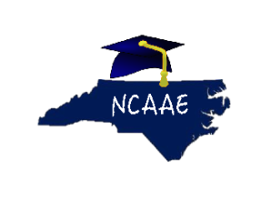Alternative Education is not an Alternative to Education.

